# **Business Acumen Cases -**

# CRM Analytics - RFM Model

## **Lecture Objective:**

1. Introduction to CRM Analytics
2. How CRM analytics can be used in business?
3. Customer Segmentation using RFM

## **Case Study:**

A company in the e-commerce sector wants to segment its customers and determine their marketing strategies according to these segments.

**For example: If the company has a 50K marketing budget - and that amount is not enough to target everyone - How would you strategize spending this budget?**

## 

## **Introduction to CRM:**

* Customer relationship management (CRM) combines practices, strategies, and technologies that companies use to manage and analyze customer interactions and data throughout the customer lifecycle.
* CRM helps businesses to gain an insight into the behavior of their customers and modify their business operations to ensure that customers are served in the best possible way.

## **How is CRM analytics used in Business?**

* **Now that we know what CRM is - how do you think CRM analytics can be useful to this business?**
* **And more importantly, let's talk about how we can use analytics to help streamline our marketing budget with this case study?**
* CRM analytics gives insights into customers and how well the sales and customer service teams are reaching them.
* Helps analyze customers' habits to retarget and optimize sales of existing customers.
* Analyzing customers, finding audiences belonging to certain behaviors, and organizing campaigns suitable for that audience.
* CRM offers you the opportunity to improve your profitability, productivity, and efficiency.

## 

## **Customer Segmentation:**

* Imagine in a company, the marketing team will launch a campaign. For efficiency because of limited resources, it must get revenue or other metrics as much as possible.
  + This means that you need to optimize your targeting criteria so you spend more on customers that will generate more revenue for the store.
* Segmenting your customers can help you focus your marketing efforts, so you can increase profits and overall customer satisfaction
* **What are the different ways in which you feel you can group your customers to focus on?**
* Variables that are very often used for customer segmentation includes:
  + Demographics
  + Psychographic (segmentation using psychological characteristics including personality, lifestyle, social status, activities, interests, opinions, and attitudes)
  + Geographic
  + Purchase Patterns
  + Customer preference for products / services etc.
* **Let's take one of these segmenting attributes and talk about how we can use this attribute to strategize our marketing budget?**

## **Customer Segmentation Using RFM Clustering Model**

* **Let's talk about another kind of segmentation - which is built from understanding the customer purchase behavior. What do you think is meant by customer purchase behavior?**
* RFM stands for **Recency**, **Frequency**, and **Monetary** **Value**.
* RFM helps the company understand the customer’s characteristics based on their historical transactions.
* To extract information and characteristics of their buying behavior, we need to analyze the RFM factor.
* Then, the RFM factor for each customer would be ranked as the RFM segment for targeted marketing campaigns.

## **RFM:**

* **Recency:** How recently a customer has made a purchase, either in months, days or weeks depending on your market’s typical purchase cycle?
* **Frequency:** How often a customer makes a purchase, typically measured over the twelve months leading up to each customer’s last purchase?
* **Monetary Value:** How much money a customer spends on purchase, either in-total or on-average over the same twelve month period?
* **Methodology:**
  + Calculate RFM score for each customer by grouping the score for R, F & M -> 1(lowest score) & 5(highest score).
  + The lower limit and upper limit of the RFM score can be chosen by the analyst based on the data range.
  + You can use intuition , or a quantile system to group the values into each score.
    - For eg: to calculate recency with below data using Quantile methodology.

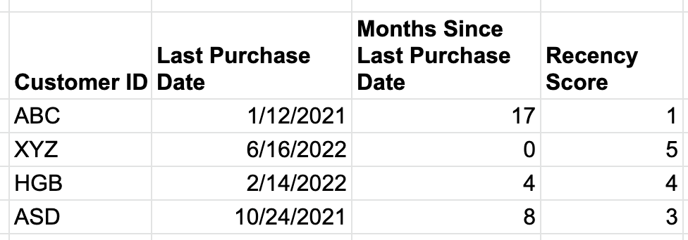

For eg: one way to group this is if “Months Since Last Purchase Date” < 20th percentile then Recency Score = 5 ;   
<40th percentile but >20th percentile = 4 and so on

* + - Example of calculating R,F,M scores using intuitive or business methodology:  
        
      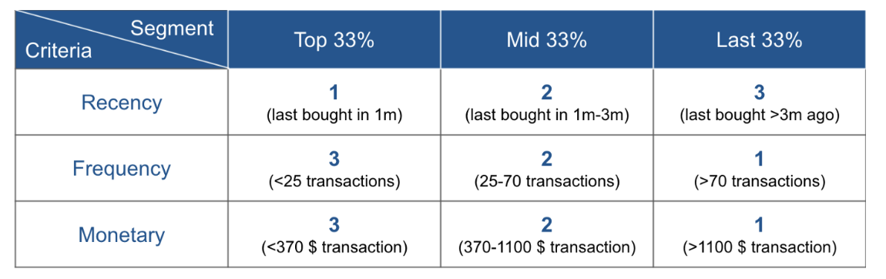
  + Concatenating all three scores together you get an easy way to divide-up your customers into segments (or “RFM cells”).
  + For eg: almost-lost but previously loyal customers (153, 1 for recency, 5 for frequency and 3 for monetary value).
* **Let's talk about how we can use these RFM scores to formulate strategies for the various customer profiles.**
* **We know in this specific used case we rate R,F & M from 1-5. 1 being lowest and 5 being highest.**
* **If we want to target high-spending new purchasers - what RFM scores would we be looking for?**
* For eg: High-spending new purchasers (514, 5 for recency, 1 for frequency and 4 for monetary value) -
  + Recency (High) - Since they are new purchasers
  + Frequency (Low) - Since they are new purchasers so they have just started purchasing
  + Monetary (High) - Since they are high spending

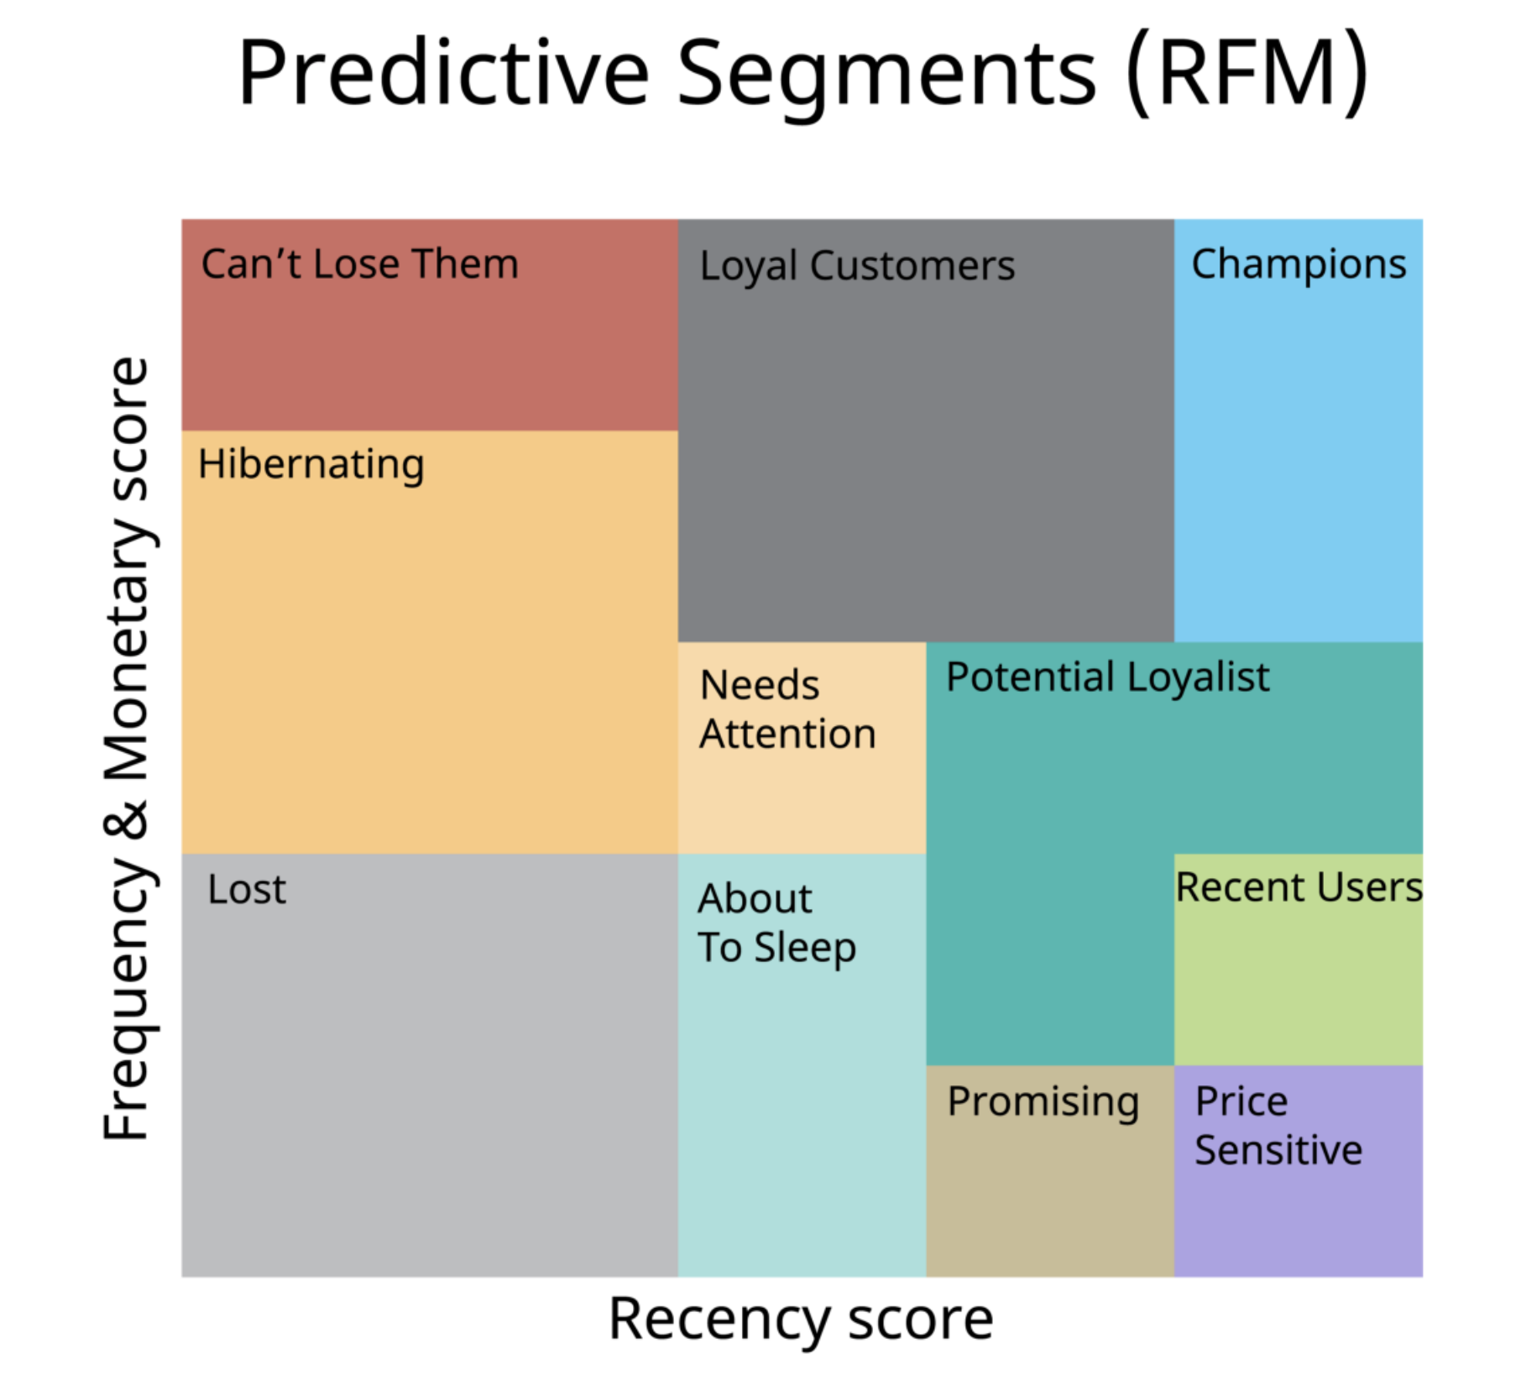

* **Can’t lose them:** This is the customer class that should not be lost, who has not shopped for a long time despite shopping very often before.
* **Hibernating / At Risk:** The class of customers who shop relatively often but have not shopped for a long time.
* **About to sleep:** This is the customer class who has not shopped frequently and has passed a certain amount of time since their shopping.
* **Need attention:** It is the customer class in the middle of the RF graph, and if it is not emphasized, it moves towards the risky group.
* **Price Sensitive / New customers:** It is the customer class who has not made frequent purchases (perhaps once) and has passed a short time since their purchase.
* **Promising:** They are customers who do not shop frequently, and a little time has passed since their shopping.
* **Potential loyalists:** Customers who shop at medium frequency and have not spent a long time since their last purchase.
* **Loyal customers:** Customers who shop frequently and whose last purchase has been a short while.
* **Champions:** They are our apple of the eye! They are customers who shop frequently and have made their last purchases in a very short time.

## 

## **Focusing marketing efforts & strategy based on RFM segmentation:**

* RFM segmentation is useful for sales, marketing and customer teams needing to focus their limited time and money on those customers for whom a change in behavior would significantly impact revenue.
* Converting lapsed customers to active or first time shoppers to repeat shoppers etc.
* **If our marketing efforts were on acquiring more customers - which segment do you think we will focus on?**
* For example, by focusing retention efforts on customers who used to be frequent, loyal and high-value purchasers (RFM segment 355) the revenue upside is obviously much greater than if they managed to retain customers who were previously infrequent low-value purchasers (RFM segment 132).
* Similarly, there’s little point in incentivising customers who are already your most loyal, frequent and high-spending customers (RFM segment 555) when spending those incentives on customers who’ve just made their first purchase and have the potential to also become loyal and valuable repeat customers (RFM segment 514, for example).

## **Conclusion & Recommendations:**

* There’s a marketing budget of 50K - how would you strategise this?
* Given that the company’s interest is in customer acquisition and retention - my main focus would be to divert this budget to groups like:
  + High Spending - New Purchasers (For Acquisitions since they are new purchasers and there’s opportunities here to make them more frequent customers who continue to spend high).
    - There’s no point prioritizing (currently) on low spending - previously loyal customers as even if they start being loyal / frequent again, their spending capacity is low and to change the spending capacity is a more difficult problem to solve.
    - So let's focus on the low hanging fruits (high impact, less effort)
  + High Spending - Previously Loyal Purchasers (For Retention)
    - Since we know they are high spending and they used to be more frequent before , we can build campaigns to retarget these customers so they are reminded to visit again.
    - Even a few customers conversion will lead to higher impact due to their high spending capacity.